South Carolina Enterprise Information System

Interface Operations Guide (IOG)

IF389 - AP Outbound Interface

Introduction

Document Purpose and Organization

The Interface Operations Guide (IOG) contains the interface specific information required for State of South Carolina Agencies to integrate with the SCEIS system. Each interface will contain a separate IOG with specific information. The IOG information will include the ADS number, description, file name(s), examples of load reports, frequency, run schedule, error conditions, etc. Additionally, the IOG will contain the file layout for the interface.

General system updates can be found on the SCEIS website, http://www.sceis.sc.gov

AP Outbound Interface
Interface ADS Number | IF389
Inbound/Outbound | Outbound
Interface Title | AP Outbound Interface
Interface Description | This outbound interface will supply SCEIS invoice data to agency legacy systems on a daily basis.  SCEIS will provide the data in a common format for agencies to pick up via FTP or manual retrieval.  The SAP document number is the key field for identifying invoice documents. If agencies have other key fields (such as client/case number), it will be their responsibility to populate this data in the invoice document. This could be in a reference or text field. It will also be the agency’s responsibility to map this data to the appropriate legacy field(s).  Outbound interface files will be created by Business Area.
Version | Version 9.0
SCEIS Point of Contact
Source System | SCEIS
Destination System | State Agency Subsystems
Interface Type | Tab-delimited text file
Mode | Asynchronous
Frequency | SCEIS will produce the files during a nightly batch cycle.
File Name(s) | Outbound interface file:  <business area>.if389.apdata.outbound.<date/time stamp>  Example:  e120.if389.apdata.outbound.090706083021
FTP Path | /<business area>/apoutb

Version Control
Version | Description of Change | Date
1.0 | Initial Version | 07/28/2009
2.0 | Changed description of reference field (#11). | 09/02/2009
3.0 | Added status ‘4’ & ‘5’ | 01/14/2010
4.0 | Added fields- Material Number, Plant, Main Asset #, Sub Asset #, Asset Trans Type, Trans Type, Chk Cash Date, Goods Recpt Date, PO Date | 02/03/2011
5.0 | Added Multiple Payee Name Fields | 02/18/2011
6.0 | Change WBS element from 8 character field to a 24 character field | 03/16/2011
7.0 | Add documentation to request resending a file or document | 04/26/2011
8.0 | Added EDI fields, expanded Payee Name 1-3 fields to 70 char length ,and removed Payee Name 4-20 fields | 08/01/2012
9.0 | Added Payment Reference field | 06/26/2020
File Layout

No. | Field Name | Type | Size | Format |  | Description
1 | Document Status | CHAR | 1 | X | Status of the SAP document:  ‘1’ - doc has posted  ‘2’ - doc has cleared (processed through a  payment run)  ‘3’ - check has been written and doc  updated w/ check number  ‘4’ – doc is Canceled(Check Canceled)  ‘5’ – doc is Reversed
2 | Document Number | CHAR | 10 | X(10) | SAP document number
3 | Document Type | CHAR | 2 | XX | SAP document type
4 | Document Date | DATE | 8 | YYYYMMDD | Vendor invoice date
5 | Posting Date | DATE | 8 | YYYYMMDD | Represents financial posting date. Controls posting period and fiscal year. (effective date)
6 | Entry Date | DATE | 8 | YYYYMMDD | Date the document was created in SAP
7 | Reference | CHAR | 16 |  | Represents vendor invoice number. The field in SAP is 16 chars, STARS only uses the first 15 chars.
8 | Gross Invoice Amount | DEC | 14 | 9(11).99 | Gross invoice amount (field is 14 digits including decimal point and 2 decimal places)
9 | Currency | CHAR | 5 | X(5) | Should be ‘USD’
10 | Header Text | CHAR | 25 | X(25) | For agency use to map legacy information
11 | Reference | CHAR | 20 | X(20) | Internal SAP Reference Key
12 | Date of Last Document Change | DATE | 8 | YYYYMMDD | The date that the document was last changed – the date that the document was posted in SAP.
13 | Date of Last Document Update | DATE | 8 | YYYYMMDD | The date that the document was last updated 0 updates refer to additions of text information such as check information, warrant numbers, etc.
14 | Reference Key 1 | CHAR | 20 | X(20) | Contains the STARS Warrant-Id sent to the STO for payment
15 | Reference Key 2 | CHAR | 20 | X(20) | If the document was created via an interface, contains the inbound interface legacy key
16 | Business Area | CHAR | 4 | XXXX | Agency code - e.g. ‘E120’
17 | Line Item Number | NUMC | 3 | 999 | Identifies the detail lines within the SAP document.
18 | Vendor Number | CHAR | 10 | X(10) | SCEIS vendor number - Standard vendors begin with 7 and are 10 characters long
19 | General Ledger Account | CHAR | 10 | X(10) | SCEIS General Ledger Account
20 | G/L Account Name | CHAR | 20 | X(20) | Description of General Ledger account
21 | Line Item Amount | DEC | 14 | 9(11).99 | Line item amount (field is 14 digits including a decimal point and 2 decimal places)
22 | Quantity | NUMC | 14 | 9(10).999 | Quantity per line item
23 | Base Unit of Measure | CHAR | 3 | XXX | ‘MI’ = Miles ; ‘TR’ = Trips
24 | Debit/Credit Indicator | CHAR | 1 | X | ‘D’ = Debit ; ‘C’ = Credit
25 | Earmarked Funds Doc | CHAR | 10 | X(10) | If applicable, the corresponding Funds Reservation Document number
26 | Earmarked Funds Line Item | NUMC | 3 | 999 | If applicable, the corresponding Funds Reservation Document line item number
27 | Cost Center | CHAR | 10 | X(10) | Division/Department
28 | Functional Area | CHAR | 16 | X(16) | Program/Mini Code
29 | Fund | CHAR | 10 | X(10) | Fund
30 | Grant | CHAR | 20 | X(20) | Grant
31 | Order Number | CHAR | 12 | X(12) | If applicable, Internal Order Number
32 | WBS Element | CHAR | 24 | X(24) | If applicable, WBS Element – Project Systems project number
33 | Line Item Text | CHAR | 50 | X(50) | For agency use to map legacy information
34 | Sales Tax Code | CHAR | 2 | XX | Type of tax
35 | Tax Jurisdiction | CHAR | 15 | X(15) | Delivery of good tax jurisdiction
36 | Assignment Number | CHAR | 18 | X(18) | Contains optional legacy client / case / claim numbers
37 | Purchase Order # | CHAR | 10 | X(10) | SCEIS purchase order number
38 | Purchase Order Item Number | NUMC | 5 | 9(5) | PO line item number
39 | Clearing Document Number | CHAR | 10 | X(10) | Proof of document ready for payment in SAP
40 | Check Number | CHAR | 13 | X(13) | Check number
41 | Check/EDI Date | DATE | 8 | YYYYMMDD | Check or EDI date
42 | Check/EDI Amount | CURR | 14 | 9(11).99 | Check or EDI amount
43 | EDI Reference Number | CHAR | 16 | X(16) | Reference Number for the EDI file sent to bank
44 | EDI Trace Number | CHAR | 23 | X(23) | Unique Number for each payment in the EDI file
45 | Reversal Document Number | CHAR | 10 | X(10) | Reversal document number
46 | Reversal Reason | CHAR | 2 | XX | Reversal reason
47 | Vendor Name 1 | CHAR | 35 | X(35) | Payee name (applicable only if One Time Vendor was used on invoice)
48 | Vendor Name 2 | CHAR | 35 | X(35) | Payee name field 2 (applicable only if One Time Vendor was used on invoice)
49 | Vendor House Number & Street | CHAR | 35 | X(35) | Payee street address (applicable only if One Time Vendor was used on invoice)
50 | Vendor City | CHAR | 35 | X(35) | Payee city (applicable only if One Time Vendor was used on invoice)
51 | Vendor Region | CHAR | 3 | XXX | Payee state (applicable only if One Time Vendor was used on invoice)
52 | Vendor Postal Code | CHAR | 10 | X(10) | Payee zip code (applicable only if One Time Vendor was used on invoice)
53 | Vendor Country | CHAR | 3 | XXX | Payee country (applicable only if One Time Vendor was used on invoice)
54 | Extract Date | DATE | 8 | YYYYMMDD | Date that the outbound interface was executed
55 | Extract Time | NUMC | 6 | HHMMSS | Time that the outbound interface was executed
56 | Material Number | CHAR | 18 | X(18) | PO Related Material Number
57 | Plant | CHAR | 4 | XXXX | PO Related Plant
58 | Main Asset Number | CHAR | 12 | X(12) | PO Related Main Asset Number
59 | Sub Asset Number | CHAR | 4 | XXXX | PO Related Sub Asset Number
60 | Asset Transaction Type | CHAR | 3 | XXX | Asset Transaction Type
61 | Transaction Type | CHAR | 3 | XXX | Shows the historical development of a financial statement item.
62 | Check Encashment Date | DATE | 8 | YYYYMMDD | Check Encashment Date (For Future Use)
63 | Purchase Order Date | DATE | 8 | YYYYMMDD | Purchase Order Date
64 | Goods Receipt Date | DATE | 8 | YYYYMMDD | PO Related Goods Receipt Date
65 | Payee Name Line 1 | CHAR | 70 | X(70) | Payee Names (For Multiple Payees)
66 | Payee Name Line 2 | CHAR | 70 | X(70) | Payee Names (For Multiple Payees)
67 | Payee Name Line 3 | CHAR | 70 | X(70) | Payee Names (For Multiple Payees)
68 | Payment Reference | CHAR | 30 | X(30) | Payment Reference for Account Number sent to vendor on ACH payments

Process Flowchart
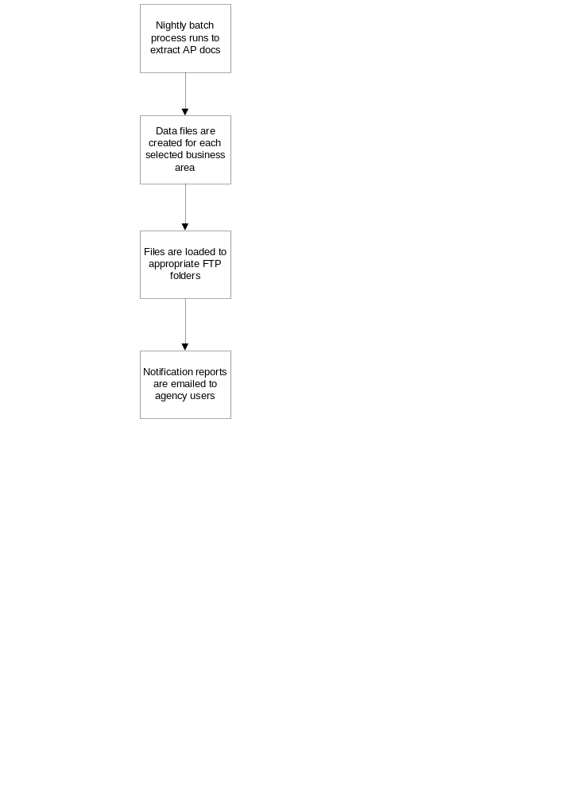
Report Examples

A notification report will be emailed to selected agency users when the interface is executed. The report displays summary interface information and is sent as an email attachment in a PDF format.

The following is an example of the interface notification report:

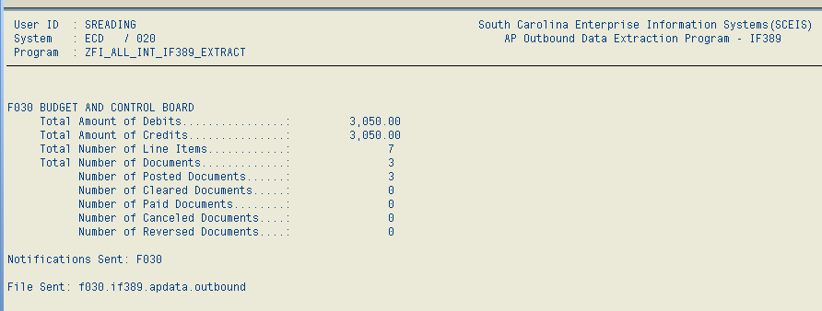
Miscellaneous Processing Notes

- The output file format is a TAB-delimited text file.

- Contact email addresses will need to be provided to SCEIS for each agency using the AP Outbound interface. Notification reports containing summary information will be emailed to these users when the interface is executed each day.

- To have an IF389 file resent to your agency folder, email interfaces@sceis.sc.gov. Please note that each file that is recreated can contain only one day’s outbound data.

- To have a document resent on an IF389 file, email interfaces@sceis.sc.gov with the document number(s) to be resent on the next regular outbound run.

- To view data that has been sent on the file, the agency with the appropriate roles can use the interface monitoring tool. The transaction is Z_AGENCY_INTERFACES. The activity report can be viewed when pressing the “IF389 AP Outbound Interface” button.

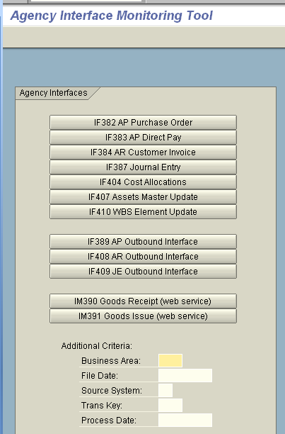
The “IF389 AP Outbound Interface” Activity Report will then look like this:

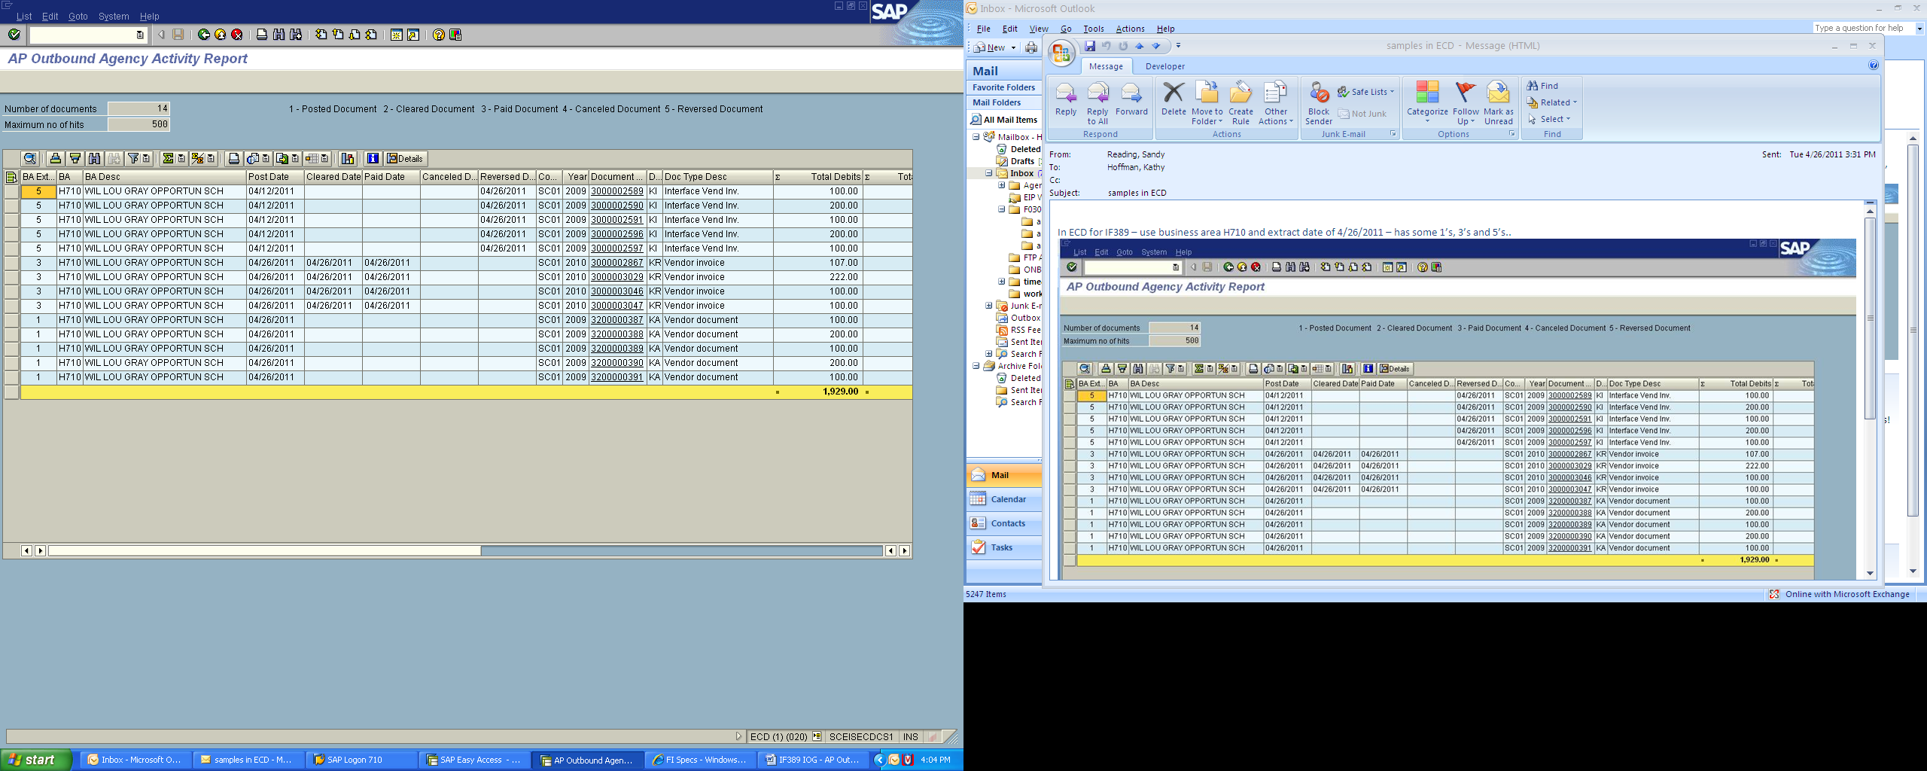

With this report, you can sort, filter, print, drill down in a document for detail, etc.
General FTP Processing Notes
The preferred method of data transfer will be via secure FTP, and SCEIS will host an FTPS server for this purpose.

There will be a folder structure set up on the server for each business area. Security will be set up appropriately on the folders so that users will only have access to their data. The files for this outbound interface will be written to a ‘/apoutb’ folder under the main folder for the business area. An example FTP file structure is shown below.

/e120
/ar
/ap
/apoutb
/e160
/apoutb
/mm
/e200
/apoutb

To send files to SCEIS‐inbound or receive files from SCEIS‐outbound interfaces, FTPS client software will be used on the agency side. Example FTP connection options are shown in the following print screen. (Using the CoreFTP desktop client software – in other clients, the options may be slightly different.)

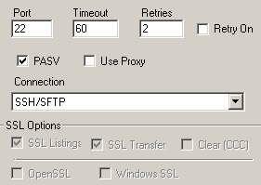

For questions or concerns regarding the File Transfer Protocol procedures, please contact the SCEIS interface team at interfaces@sceis.sc.gov.

