South Carolina Enterprise Information System

Interface Operations Guide (IOG)

IF409 - JE Outbound Interface

Introduction

Document Purpose and Organization

The Interface Operations Guide (IOG) contains the interface specific information required for State of South Carolina Agencies to integrate with the SCEIS system. Each interface will contain a separate IOG with specific information. The IOG information will include the ADS number, description, file name(s), examples of load reports, frequency, run schedule, error conditions, etc. Additionally, the IOG will contain the file layout for the interface.

General system updates can be found on the SCEIS website, http://www.sceis.sc.gov

JE Outbound Interface
Interface ADS Number | IF409
Inbound/Outbound | Outbound
Interface Title | JE Outbound Interface
Interface Description | This outbound interface will supply SCEIS Journal Entry data to agency legacy systems on a daily basis.  SCEIS will provide the data in a common format for agencies to pick up via FTP or manual retrieval.  The SAP document number is the key field for identifying journal entry documents. If agencies have other key fields (such as JV information number), it will be their responsibility to populate this data in the invoice document. This could be in a reference or text field. It will also be the agency’s responsibility to map this data to the appropriate legacy field(s).  Outbound interface files will be created by Business Area.
Version | Version 2.0
SCEIS Point of Contact
Source System | SCEIS
Destination System | State Agency Subsystems
Interface Type | Tab-delimited text file
Mode | Asynchronous
Frequency | SCEIS will produce the files during a nightly batch cycle.
File Name(s) | Outbound interface file:  <business area>.if409.jedata.outbound.<date/time stamp>  Example:  e120.if409.jedata.outbound.090706083021
FTP Path | /<business area>/jeoutb

Version Control
Version | Description of Change | Date
1.0 | Initial Version | 01/21/2011
1.1 | Added fields- main asset #, sub asset #, asset trans type, material #,& plant | 02/03/2011
1.2 | Split Total Gross into Total Debits and Total Credits. | 02/28/2011
1.3 | Changed WBS Element from 8 character field to a 24 character field | 03/16/2011
2.0 | Add documentation to request resending a file or document | 04/26/2011
File Layout

No. | Field Name | Type | Size | Format |  | Description
1 | Business Area | CHAR | 4 | XXXX | Agency code - e.g. ‘E120’
2 | Document Status | CHAR | 1 | X | Status of the SAP document:  ‘1’ – Parked  ‘2’ – Parked waiting on Agency action  ‘3’ – Parked waiting on CG approval  ‘4’ – Delete Parked  ‘5’ – Posted  ‘6’ – Reversed
3 | Document Number | CHAR | 10 | X(10) | SAP document number
4 | Document Type | CHAR | 2 | XX | SAP document type
5 | Document Date | DATE | 8 | YYYYMMDD | Journal Entry date
6 | Posting Date | DATE | 8 | YYYYMMDD | Represents financial posting date. Controls posting period and fiscal year. (effective date)
7 | Entry Date | DATE | 8 | YYYYMMDD | Date the document was created in SAP
8 | Reference | CHAR | 16 |  | Represents Customer invoice number. The field in SAP is 16 chars, STARS only uses the first 15 chars
9 | Total Debits | DEC | 14 | 9(11).99 | Total debit amount of document (field is 14 digits including decimal point and 2 decimal places)
10 | Total Credits | DEC | 14 | 9(11).99 | Total credit amount of document (field is 14 digits including decimal point and 2 decimal places)
11 | Currency | CHAR | 5 | X(5) | Should be ‘USD’
12 | Header Text | CHAR | 25 | X(25) | For agency use to map legacy information
13 | Date of Last Document Change | DATE | 8 | YYYYMMDD | The date that the document was last changed – the date that the document was posted in SAP
14 | Date of Last Document Update | DATE | 8 | YYYYMMDD | The date that the document was last updated
15 | Reference Key 1 | CHAR | 20 | X(20) | Contains the STARS Warrant-Id sent to the STO for payment
16 | Reference Key 2 | CHAR | 20 | X(20) | If the document was created via an interface, contains the inbound interface legacy key
17 | Line Item Number | NUMC | 3 | 999 | Identifies the detail lines within the SAP document.
18 | Line Item Amount | DEC | 14 | 9(11).99 | Line item amount (field is 14 digits including a decimal point and 2 decimal places)
19 | Debit/Credit Indicator | CHAR | 1 | X | ‘D’ = Debit ; ‘C’ = Credit
20 | General Ledger Account | CHAR | 10 | X(10) | SCEIS General Ledger Account
21 | G/L Account Name | CHAR | 20 | X(20) | Description of General Ledger account
22 | Quantity | NUMC | 14 | 9(10).999 | Quantity per line item
23 | Base Unit of Measure | CHAR | 3 | XXX | ‘MI’ = Miles ; ‘TR’ = Trips
24 | Earmarked Funds Doc | CHAR | 10 | X(10) | If applicable, the corresponding Funds Reservation Document number
25 | Earmarked Funds Line Item | NUMC | 3 | 999 | If applicable, the corresponding Funds Reservation Document line item number
26 | Fund | CHAR | 10 | X(10) | Fund
27 | Grant | CHAR | 20 | X(20) | Grant
28 | Cost Center | CHAR | 10 | X(10) | Division/Department
29 | Functional Area | CHAR | 16 | X(16) | Program/Mini Code
30 | Order Number | CHAR | 12 | X(12) | If applicable, Internal Order Number
31 | WBS Element | CHAR | 24 | X(24) | If applicable, WBS Element – Project Systems project number
32 | Sales Tax Code | CHAR | 2 | XX | Type of tax
33 | Line Item Text | CHAR | 50 | X(50) | For agency use to map legacy information
34 | Assignment Number | CHAR | 18 | X(18) | Contains optional legacy information
35 | Reverse Document Number | CHAR | 10 | X(10) | If status is “5 (posted)” – this is the document that was reversed. If status is “6 (reversed)” – this is the reversal document.
36 | Reversal Reason | CHAR | 2 | XX | Reversal reason
37 | Extract Date | DATE | 8 | YYYYMMDD | Date that the outbound interface was executed
38 | Extract Time | NUMC | 6 | HHMMSS | Time that the outbound interface was executed
39 | Transaction Type | CHAR | 3 | XXX | Transaction Type
40 | Material Number | CHAR | 18 | X(18) | Material Number
41 | Plant | CHAR | 4 | XXXX | Plant
42 | Main Asset Number | CHAR | 12 | X(12) | Main Asset Number
43 | Sub Asset Number | CHAR | 4 | XXXX | Sub Asset Number
44 | Asset Transaction Type | CHAR | 3 | XXX | Asset Transaction Type

Process Flowchart
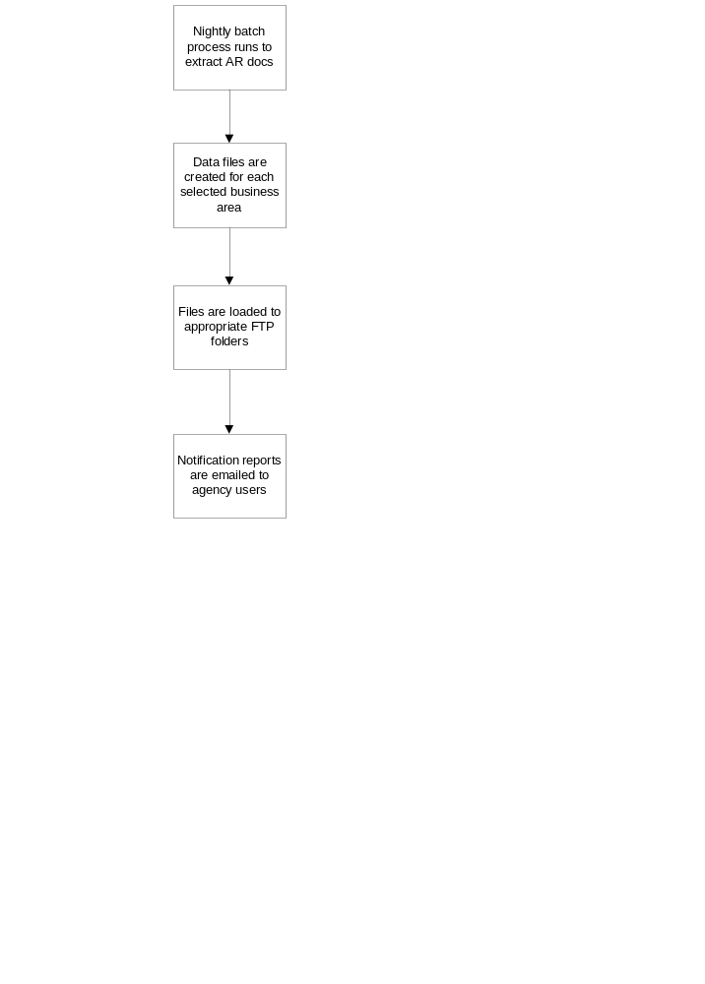
Report Examples

A notification report will be emailed to selected agency users when the interface is executed. The report displays summary interface information and is sent as an email attachment in a PDF format.

The following is an example of the interface notification report:

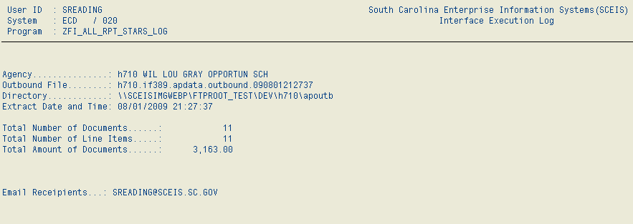
Miscellaneous Processing Notes

- The output file format is a TAB-delimited text file.

- Contact email addresses will need to be provided to SCEIS for each agency using the JE Outbound interface. Notification reports containing summary information will be emailed to these users when the interface is executed each day.

- To have an IF409 file resent to your agency folder, email interfaces@sceis.sc.gov. Please note that each file that is recreated can contain only one day’s outbound data.

- To have a document resent on an IF409 file, email interfaces@sceis.sc.gov with the document number(s) to be resent on the next regular outbound run.

- To view data that has been sent on the file, the agency with the appropriate roles can use the interface monitoring tool. The transaction is Z_AGENCY_INTERFACES. The activity report can be viewed when pressing the “IF409 JE Outbound Interface” button.

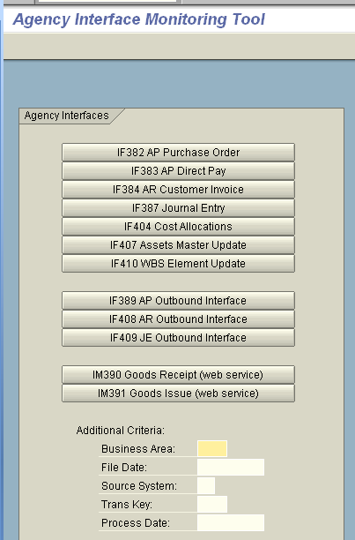
The “IF409 JE Outbound Interface” Activity Report will then look like this:

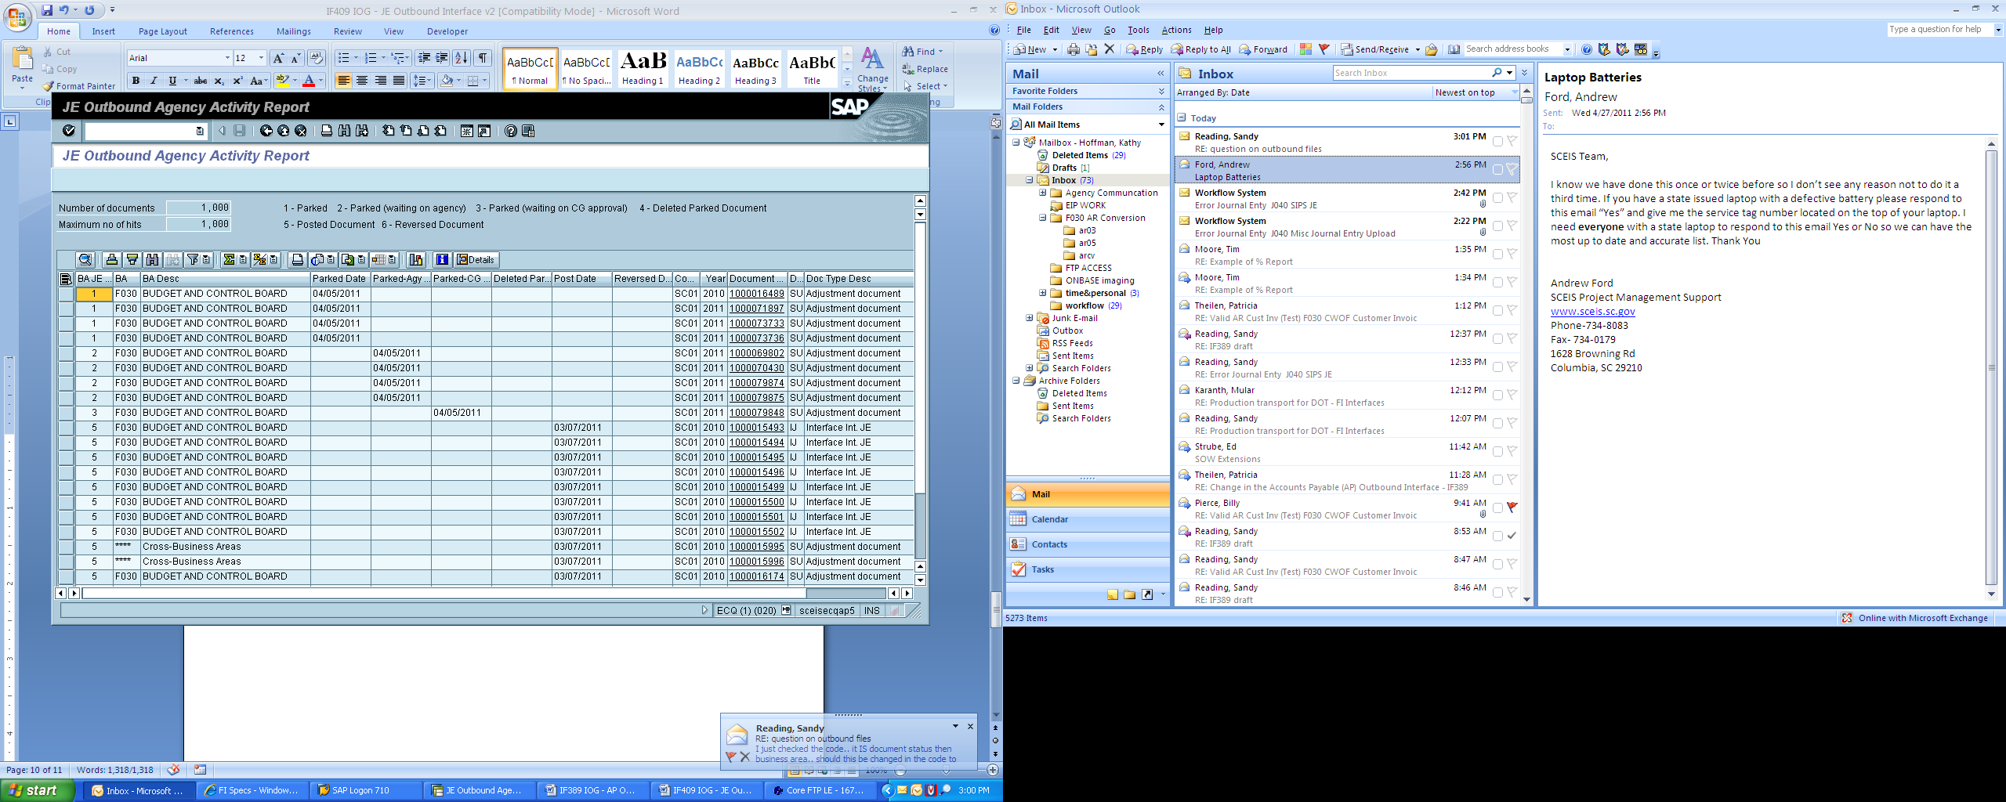

With this report, you can sort, filter, print, drill down in a document for detail, etc.

General FTP Processing Notes
The preferred method of data transfer will be via secure FTP, and SCEIS will host an FTPS server for this purpose.

There will be a folder structure set up on the server for each business area. Security will be set up appropriately on the folders so that users will only have access to their data. The files for this outbound interface will be written to a ‘/jeoutb’ folder under the main folder for the business area. An example FTP file structure is shown below.

/e120
/je
/ap
/apoutb
/jeoutb

/e160
/jeoutb
/mm
/e200
/jeoutb

To send files to SCEIS‐inbound or receive files from SCEIS‐outbound interfaces, FTPS client software will be used on the agency side. Example FTP connection options are shown in the following print screen. (Using the CoreFTP desktop client software – in other clients, the options may be slightly different.)

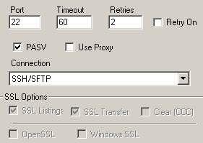

For questions or concerns regarding the File Transfer Protocol procedures, please contact the SCEIS interface team at interfaces@sceis.sc.gov.

