**South Carolina Enterprise Information System**

**Interface Operations Guide (IOG)**

**IF418 – Automated Deposit Interface**

**Introduction**

***Document Purpose and Organization***

The Interface Operations Guide (IOG) contains the interface specific information required for State of South Carolina Agencies to integrate with the SCEIS system. Each interface will contain a separate IOG with specific information. The IOG information will include the ADS number, description, file name(s), examples of load reports, frequency, run schedule, error conditions, etc. Additionally, the IOG will contain the file layout for the interface.

General system updates can be found on the SCEIS website, <http://www.sceis.sc.gov>

**Journal Entry Inbound Interface**

|  |  |
| --- | --- |
| **Interface ADS Number** | IF418 |
| **Inbound/Outbound** | Inbound |
| **Interface Title** | Automated DepositInbound Interface |
| **Interface Description** | This interface provides an automated method for users to create Automated Deposit  documents.  In SCEIS, users refer to these as Interface Deposits (ID) documents.  The sending agency will translate their current legacy system data into SAP data elements and upload through the Interface.  With this interface, there will be a specific process created for Automated Deposits. The process will create a parked document for the validated bank deposit, attach an image of the validated bank deposit slip (or equivalent) and then workflow the document to the in-box of the STO General Depositary team for approval. |
| **Version** | Version 8.0 |
| **SCEIS Contact** |  |
| **Source System** | State Agency Subsystems |
| **Destination System** | SCEIS |
| **Interface Type** | Tab-delimited text file |
| **Mode** | Asynchronous |
| **Frequency** | The Agencies will transmit the interface files as needed. Files have the option of being processed upon receipt by SCEIS (at 30 to 45 minute intervals throughout the day) or being held and processed in a batch cycle at night. |

|  |  |
| --- | --- |
| **File Name(s)** | Inbound interface file:  <bus. area>.<source system>.if418.deposit.inbound.<date/time stamp>  Example:  e120.a1.if418.deposit.inbound.090706083012  ---  Error file:  <bus. area>.<source system>.if418.deposit.errors.<original date/time stamp>.<creation date/time stamp>  Example:  e120.a1.if418.deposit.errors.090706083012.090706091512  ---  Valid confirmation file:  <bus. area>.<source system>. if418.deposit.confirmvalid.<original date/time>.<creation date/time>  Example:  e120.a1.if418.deposit.confirmvalid.090706083021.090706091512  ---  Error confirmation file:  <bus. area>.<source system>.if418.deposit.confirmerror.<original date/time>.<creation date/time>  Example:  e120.a1.if418.deposit.confirmerror.090706083021.090706091512 |
| **FTP Path** | Determined by the security requirements of the sending Agency. |
| **Manual Upload** | Users with appropriate permissions will be able to upload properly formatted, tab-delimited text files to the interface for processing. The SAP transaction code for uploading an Automated Deposit data file is ZIF419_DEPOSIT_UPLOAD. |

**Version Control**

|  |  |  |
| --- | --- | --- |
| **Version** | **Description of Change** | **Date** |
| 1.0 | Initial Version | 01/10/2013 |
| 2.0 | Update field descriptions | 01/16/2013 |
| 3.0 | Update field descriptions and file layout | 01/30/2013 |
| 4.0 | Update Line Item Text Filed description | 2/25/2013 |
| 5.0 | Update File layout, Header Segment, Line 10--Doc. Type correction | 03/07/2013 |
| 6.0 | Update Printscreens and some verbiage errors; change the cash G/L offset account. | 03/15/2013 |

**File Layout**

|  |  |  |  |  |  |  |
| --- | --- | --- | --- | --- | --- | --- |
| **No.** | **Field Name** | **Req/ Opt** | **Type** | **Size** | **Format** | **Description** |
| ***ID Segment*** | |  |  |  |  |  |
| 1 | Business Area | R | CHAR | 4 | XXXX | Agency Code - e.g. P280 |
| 2 | Source System Identifier | R | CHAR | 2 | XX | Agency specific Code to represent source system. Agencies discretion to use 2 unique characters as needed. |
| 3 | File Date | R | DATE | 8 | YYYYMMDD | File creation date - e.g. 20090531 |
| 4 | File Time | R | TIME | 6 | HHMMSS | File creation time in 24hr format - e.g. 183622 |
| 5 | Transaction Key | R | CHAR | 4 | XXXX | Identifies the type of SAP transaction:  Key Transaction  DP01 Deposits |
| 6 | Approval Status | R | CHAR | 1 | X | Space. Currently not used |
| 7 | Process | R | CHAR | 1 | X | 1 = Deferred Batch processing (picked up at 4am) Space = Immediate processing (picked up within 30 mintues) |
| 8 | Approval Grouping | R | CHAR | 1 | X | Not used |
| ***Header Segment*** | |  |  |  |  |  |
| 9 | Header Sequence Number | R | NUMC | 4 | 9999 | Identifies the SAP documents in the interface file. All lines making up the first document in the file should have '0001' in this field; the lines for the second document should have '0002', etc. |
| 10 | Document Type | R | CHAR | 2 | XX | Based on Transaction Key:  Key Document Type  DP01 ID (Interface Deposit) |
| 11 | Document Date | R | DATE | 8 | YYYYMMDD | This will be the date of the document and SHOULD be equal to the validated deposit date. |
| 12 | Posting Date | R | DATE | 8 | YYYYMMDD | Represents financial posting date. Controls posting period and fiscal year. (effective date) |
| 13 | Reference | R | CHAR | 16 | X(16) | First 8 characters must be the FMS bank account code for the bank where the deposit was completed. This field will be have a validation check to ensure a valid account code is used. Will be stored in the header reference field of the posted document header. The final 7 characters will contain the Sub-Account number if required by Agency (DMV and DHEC). |
| 14 | Header Text | R | CHAR | 25 | X(25) | Will be used to house the unique identifier used in the creation of the Key Indicator. Agency can use any unique identifier from a source system or recomendaiton is Bank, date, and deposit number (ex: BOA 010513 12345) |
| ***Data Segment*** | |  |  |  |  |  |
| 15 | Line Item Number | R | NUMC | 3 | 999 | Identifies the detail lines within the SAP document. The first line in the document should have '001', the second line '002', etc. When a new document is started (i.e. Header Sequence Number increments), Line Item Number starts back at '001'. |
| 16 | Gross Document Amount | R | DEC | 14 | 9(11).99 | Gross document amount (field is 14 digits including a decimal point and 2 decimal places). This is the total amount of the deposit from the validated deposit slip. There should be one cash line that equals this amount on each document. |
| 17 | GL Account | R | CHAR | 10 | X(10) | SCEIS Chart of Accounts to be provided for crosswalk/mapping purposes. |
| 18 | Line Item Amount | R | DEC | 14 | 9(11).99 | Line item amount (field is 14 digits including a decimal point and 2 decimal places). |
| 19 | Debit/Credit Ind | R | CHAR | 1 | X | "D" = Debit, "C" = Credit |
| 20 | Cost Center | R | CHAR | 10 | X(10) | List will be available by agency once converted to SCEIS codes |
| 21 | Functional Area | R | CHAR | 16 | X(16) | List will be available by agency once converted to SCEIS codes |
| 22 | Fund | R | CHAR | 10 | X(10) | List will be available by agency once converted to SCEIS codes |
| 23 | Grant | R | CHAR | 12 | X(12) | List will be available by agency once converted to SCEIS codes. If not grant related default value is "NOT RELEVANT". |
| 24 | Internal Order | O | CHAR | 12 | X(12) | If applicable, list will be available by agency once converted to SCEIS codes |
| 25 | WBS | O | CHAR | 24 | X(24) | Work Breakdown Structure - If applicable, list will be available by agency once converted to SCEIS codes |
| 26 | Line Item Text | O | CHAR | 50 | X(50) | Available for agency use to map legacy information. For SC-BOSS and SC-PORTAL, this field would be available for the unique agency information which assists in identifying the transaction they are receipting for the other agencies. |
| 27 | Assignment Number | O | CHAR | 18 | X(18) | Contains optional legacy client / case / claim numbers |

**Note**: Every record on the input file contains all data fields. The ID and Header segment fields are repeated on every record.

There may be multiple lines of revenue on each document. However, there should only be one (1) cash line. **The cash line should only have the following accounting fields completed: G/L (1000040000), Dr/CR indicator and total dollar amount of the deposit**. The Splitter will take care of the balance of the cash entry(ies).

**Process Flowchart**



**Report Examples**

There are several reports that are emailed back to the agency based on the Source System ID field. Email recipients are associated with each agency system and the reports are sent as email attachments in a PDF format. The following are examples of a notification report, a successful report and an error report. A transmittal notification report is sent when the file is received by the system. The successful and error reports are sent when the data is processed by the system. The reports may vary slightly based on the interface type, but will be similar to the examples shown.

The following is an example of a transmittal notification report:

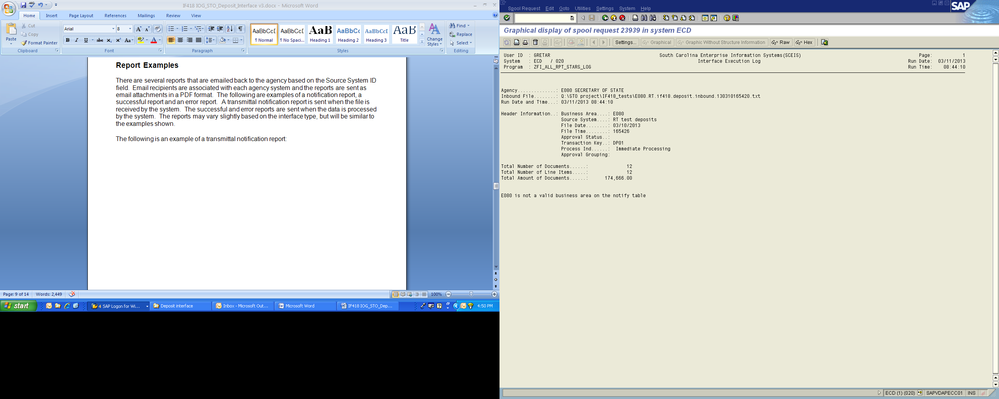

The following is an example of a successful report:

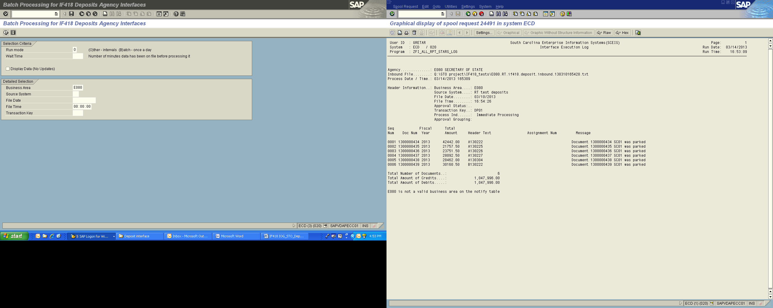

The following is an example of an error report:

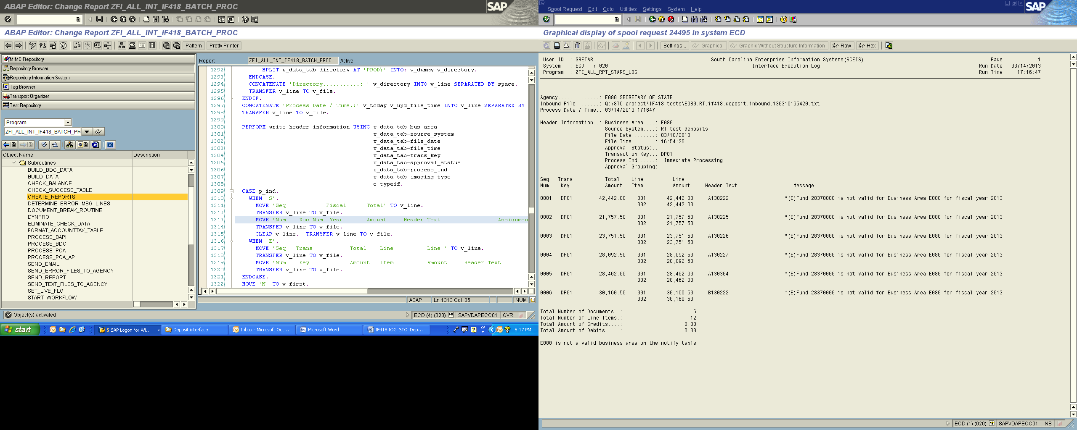

**Confirm valid text file layout**

An optional valid confirmation file can be created (on/off based on source system), if requested. This will contain the documents that were posted for a specific interface file and will be written back to the same FTP folder as the inbound file.

|  |  |  |  |  |  |  |  |  |  |  |
| --- | --- | --- | --- | --- | --- | --- | --- | --- | --- | --- |
| **No.** | **Field Name** | | | **Type** | **Size** | | **Format** | **Description** | | |
|  |  |  |  | | |  | | | |
| 1 | Business Area | | | CHAR | 4 | | XXXX | | Agency Code - e.g. E120 | | |
| 2 | Source System Identifier | | | CHAR | 2 | | XX | | Agency specific Code to represent source system.  **Note: Same as on inbound file** | | |
| 3 | File Date | | | DATE | 8 | | YYYYMMDD | | File creation date - e.g. 20090531 | | |
| 4 | File Time | | | TIME | 6 | | HHMMSS | | File creation time in 24hr format - e.g. 183622 | | |
| 5 | Transaction Key | | | CHAR | 4 | | XXXX | | Identifies the type of SAP transaction:  Key Transaction  DP01 Deposits | | |
| 6 | Header Sequence number | | | NUMC | 4 | | 9999 | | Identifies the SAP documents in the interface file. **Note: Same as on inbound file** | | |
| 7 | Line Item Number | | | NUMC | 3 | | 999 | | Only the first line of Document is returned  **Note: Same as on inbound file** | | |
| 8 | Document Header Text | | | CHAR | 25 | | X(25) | | Will be used to house the unique identifier used in the creation of the Key Indicator. Agency can use any unique identifier from a source system or recomendaiton is Bank, date, and deposit number (ex: BOA 010513 12345) | | |
| 9 | Gross Invoice Amount | | | DEC | 14 | | 9(11).99 | | Gross Invoice amount (field is 14 digits including decimal point and 2 decimal places) | | |
| 10 | SAP Document Number | | | CHAR | 10 | | X(10) | | SAP assigned document number | | |
| 11 | Line Item Amount | | | DEC | 14 | | 9(11).99 | | Line Item Amount (field is 14 digits including a decimal point and 2 decimal places) | | |
| 12 | Debit/Credit Indicator | | | CHAR | 1 | | X | | "D" = Debit "C" = Credit | | |
| 13 | Assignment Number | | | CHAR | 18 | | X(18) | | Contains optional legacy client / case / claim numbers | | |
| 14 | Receive error file | | | CHAR | 1 | | X | | Setting on Source control table for agency receiving an error file ( “X” = receive error file ) | | |
| 15 | Fiscal Year | | | DEC | 4 | | 9999 | | Fiscal year of Document | | |
| 16 | Message | | | CHAR | 132 | | X(132) | | Any warning messages that are returned from posting and a message stating document was successfully posted. | | |

**Confirm error text file layout**

An optional error confirmation file can be created (on/off based on source system), if requested. This will contain the documents that had errors for a specific interface file and will be written back to the same FTP folder as the inbound file.

|  |  |  |  |  |  |  |  |  |  |
| --- | --- | --- | --- | --- | --- | --- | --- | --- | --- |
| **No.** | **Field Name** | **Type** | **Size** | **Format** | | | | **Description** | |
|  |  |  |  |  | | | |  | |
|  | |  | | |  |  | | |  |
| 1 | Business Area | CHAR | 4 | XXXX | | | Agency Code - e.g. E120 | | |
| 2 | Source System Identifier | CHAR | 2 | XX | | | Agency specific Code to represent source system.  **Note: Same as on inbound file** | | |
| 3 | File Date | DATE | 8 | YYYYMMDD | | | File creation date - e.g. 20090531 | | |
| 4 | File Time | TIME | 6 | HHMMSS | | | File creation time in 24hr format - e.g. 183622 | | |
| 5 | Transaction Key | CHAR | 4 | XXXX | | | Identifies the type of SAP transaction:  Key Transaction  DP01 Deposits | | |
| 6 | Header Sequence number | NUMC | 4 | 9999 | | | Identifies the SAP documents in the interface file. **Note: Same as on inbound file** | | |
| 7 | Line Item Number | NUMC | 3 | 999 | | | First line time of document  **Note: Same as on inbound file** | | |
| 8 | Document Header Text | CHAR | 25 | X(25) | | | Will be used to house the unique identifier used in the creation of the Key Indicator. Agency can use any unique identifier from a source system or recomendaiton is Bank, date, and deposit number (ex: BOA 010513 12345) | | |
| 9 | Gross Invoice Amount | DEC | 14 | 9(11).99 | | | Gross Invoice amount (field is 14 digits including decimal point and 2 decimal places) | | |
| 10 | Sap Document Number | CHAR | 10 | X(10) | | | Blank for Error File | | |
| 11 | Line Item Amount | DEC | 14 | 9(11).99 | | | Line Item Amount (field is 14 digits including a decimal point and 2 decimal places) | | |
| 12 | Debit/Credit Indicator | CHAR | 1 | X | | | "D" = Debit "C" = Credit | | |
| 13 | Assignment Number | CHAR | 18 | X(18) | | | Contains optional legacy client / case / claim numbers | | |
| 14 | Receive error file | CHAR | 1 | X | | | Setting on Source control table for agency receiving an error file | | |
| 15 | Fiscal Year | DEC | 4 | 9999 | | | Fiscal year of Document | | |
| 16 | Message | CHAR | 132 | X(132) | | | Any error messages that are returned from posting. | | |

**Miscellaneous Processing Notes**

* The file format is a TAB-delimited text file.
* All records within the file have three parts.
  + ***ID S*egment** contains systems information to specify how the file will be processed. It also contains information to uniquely identify a transaction by the source system that created it. Important: The data in the ID Segment should be the same for every record on the file.
  + ***HEADER*** **Segment** has the header level information for the SCEIS transaction.
  + ***DATA* Segment** contains the line item information for the SCEIS transaction.
* Each file sent for processing will be uniquely identified by the combination of Business Area, Source System ID, File Date and File Time. Each combination of this data will be logged by the system and any subsequent files sent with same combination will be rejected as duplicates.
* Agency contact email addresses will need to be provided to SCEIS for each agency / subsystem that will use the interface. This information will be requested as part of a testing and acceptance process for each agency system. Transmittal controls, Valid / Error reports, etc will be emailed to these designated users as files are processed by the interface. In the examples below, notifications for system “A1” would be emailed to Joe and Mary; Tom would get the emails for the “B1” system.

Agency System Email

E120 A1 joe@agency.gov

E120 A1 mary@agency.gov

E120 B1 tom@agency.gov

* As each interface file is processed, an error file (containing only the documents that do not post) will be written back to the same directory as the inbound file. The file layout of the error file is the same as the inbound file. The error codes for the documents are sent back via the error report. Agencies can opt out of this error file creation on a per-system basis.
* As each record is processed, a validation check will be completed to ensure that the GL account (data segment 17) is valid for the agency to post against (GL account Auth Group).
* The authorized G/L accounts are as follows:
  + 13002*
  + 240003*
  + 4*
  + 5*

**General FTP Processing Notes**

The preferred method of data transfer will be via secure FTP, and SCEIS will host an FTPS server for this purpose.

There will be a folder structure set up on the server for each business area. Sub-folders will be created if necessary based on the security requirements of the sending agency. Security will be set up appropriately on the folders so that users will only have access to their data.

In the example below there are separate AR and AP interface folders for business area E120. On the other hand for E160, all interfaces would use the same FTP folder - “/e160”.

/e120

/ar

/ap

/vendor

/e160

/e200

/fi

/mm

To send files to SCEIS‐inbound or receive files from SCEIS‐outbound interfaces, FTPS client software will be used on the agency side. Example FTP connection options are shown in the following print screen. (Using the CoreFTP desktop client software – in other clients, the options may be slightly different.)



Any questions/concerns regarding the File Transfer Protocol procedures can be directed to the SCEIS Interface team via e‐mail: [interfaces@sceis.sc.gov](mailto:interfaces@sceis.sc.gov).